New grooved block rail profile 53K2 (MSzTS52) production: a better performance for Tram applications
Our grooved block rails are manufactured following the EN14811 standard, meeting the same quality standards as conventional grooved rails. Grooved block rails have considerable advantages over conventional grooved rails:
- No rail web (the vertical part linking the head and the foot of a rail): 50% less height. Only 70 mm in height, which considerably reduces construction costs.
- Less weight: 5-10% lighter
- Reduced noise: 5-10 dB less (due to not having rail web)
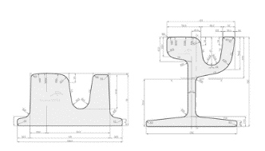

Grooved block rail vs. grooved rail

When it comes to performance, grooved block rails show excellent bending capabilities even down to Radius 20-25m. In addition, tests have shown improved stress capabilities for tram and even heavy rail networks when compared to conventional grooved rails.
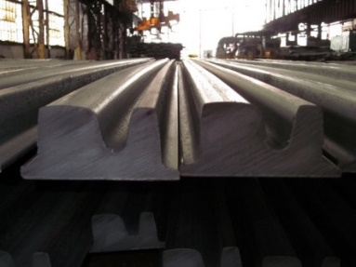
ArcelorMittal Europe – Long Products produces two grooved block rail profiles: 53K2 (MSzTS52), and 57K2 (LK1). The main difference is the wider grooved width in the case of 53K2 (MSzTS52) with 45mm. Our grooved block rails have been installed in a variety of countries including: Germany, France, Italy, Hungary, Poland, Czech Republic, Russia, Belarus, and in the United States (New York City, Washington, Portland, Dallas and Pennsylvania).

One of the world's largest tram networks running on ArcelorMittal rails
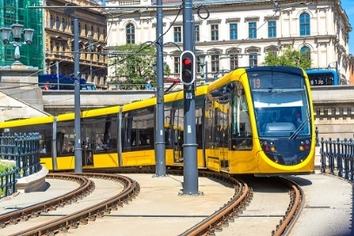
The Budapest tramway is the second most important part of the city's transit system (apart from the bus network). In operation since 1866, it is one of the world's largest tram networks, with 33 lines operating on more than 150 kilometres of total route. It carries almost 100 million more passengers annually than the Budapest Metro.
Budapest trams aim to improve the competitiveness of the city and its region but also to contribute to the implementation of a sustainable, liveable, attractive and healthy urban environment.
To complete the tram lines 49, 56, 61 and extend line 17, ArcelorMittal is supplying over 1,000 tonnes of grooved block rails produced in Rodange. Onsite deliveries of 600 tonnes have already started and will continue up to the completion in 2018.
More info: http://rails.arcelormittal.com/products/tram-rails

