Annex A: BOX LABEL

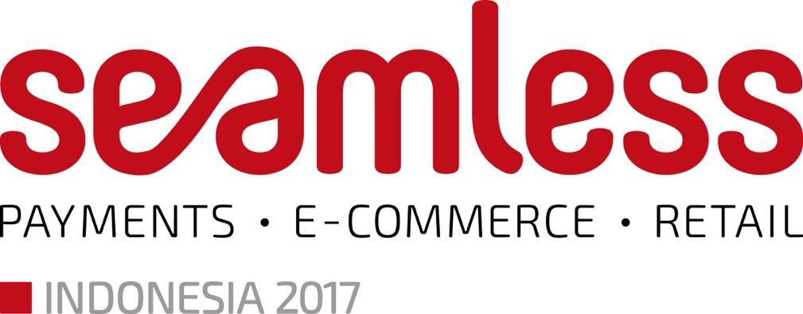

Exhibition Days: 10-11 October 2017
Deliver only on 9 October 2017 onwards
PROPERTY OF

(Please indicate name of company & booth number)

To: Ballroom 1-2, Level L
Pullman Central Park, Jakarta, Indonesia

Podomoro City
Jl. Let. Jend S Parman Kav 28 Jakarta Barat
11470 JAKARTA INDONESIA

Attention: Daniel Kristanto Gideon Lubis

Senior Sales Manager, Pullman Central Park
Tel: +62 815 1050 5878

E-mail: H7536-SB5@accor.com

All parcels are only to be delivered on the set-up day due to limited storage area. All delivery prior to 9 October 2017 will not be accepted.

Name of sender
Company
Tel / Mobile
Contents

